**User Manual**

**How to run the application:**

**Prerequisite:**

* Java SDK

**Steps need to follow:**

* Editor we used here is Notepad++
* Open Command Prompt in order to compile and execute the project.
* Now, copy the path where the project has been saved into the command prompt.
* If the copied path in command prompt is correct then the interface is ready to compile and execute the java files.

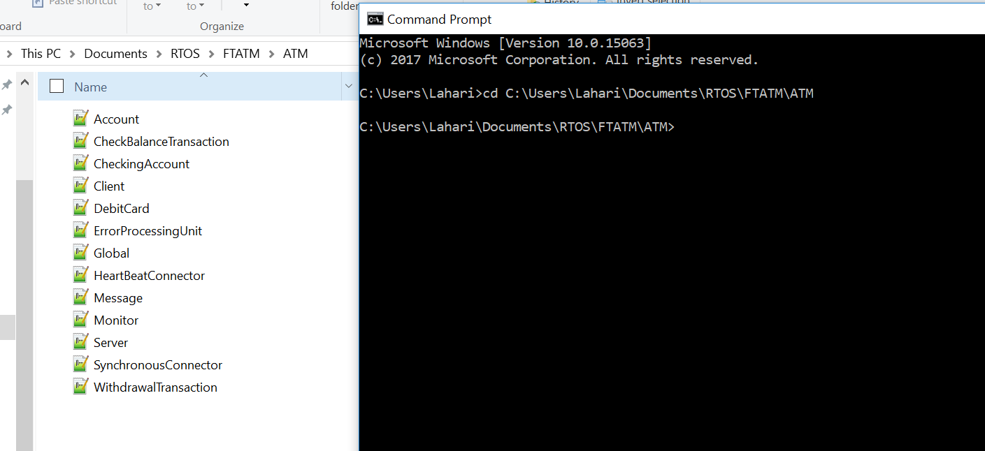

**Fig: 1**

* Compile the file named “Global.java” using command “**javac Global.java**”.
* After Compilation, intermediate bytecodes of all files will be generated.

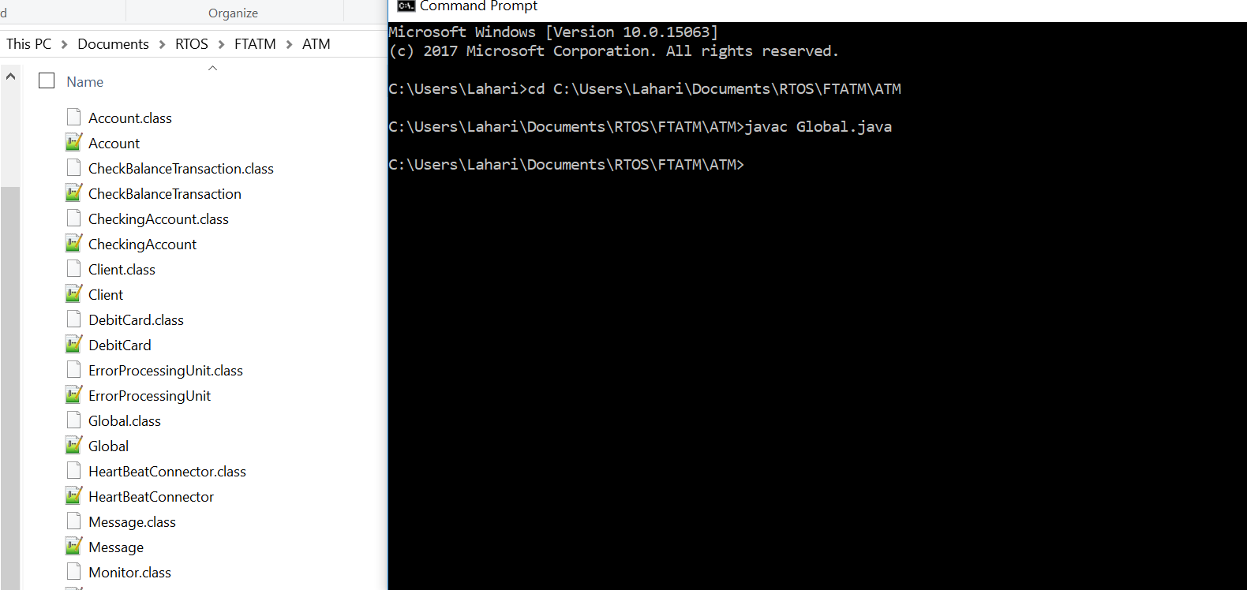

**Fig: 2**

* After successful compilation, execute the same file using command “java Global” and we get the output as given below :

**DISPLAY:**

* The output shows us Fault Tolerance ATM system which gives two options for customer whether to “check Balance” and/or “withdraw”

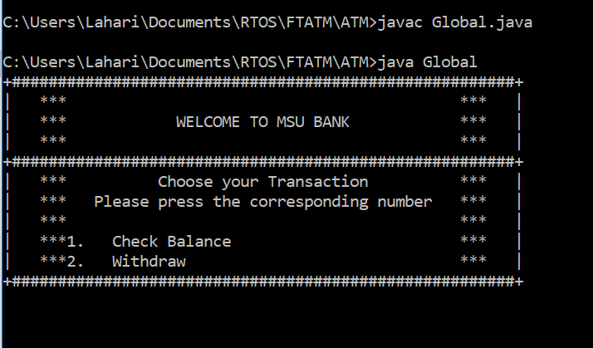

**Fig: 3**

**CHECK BALANCE FOR 3001:**

* Initially, the end user wants to check the balance with CardId: 3001 and PIN: 3001, which first checks if a CardId matches the PIN, now it returns an account number and then reads the balance amount for account number:1000 which is $200.

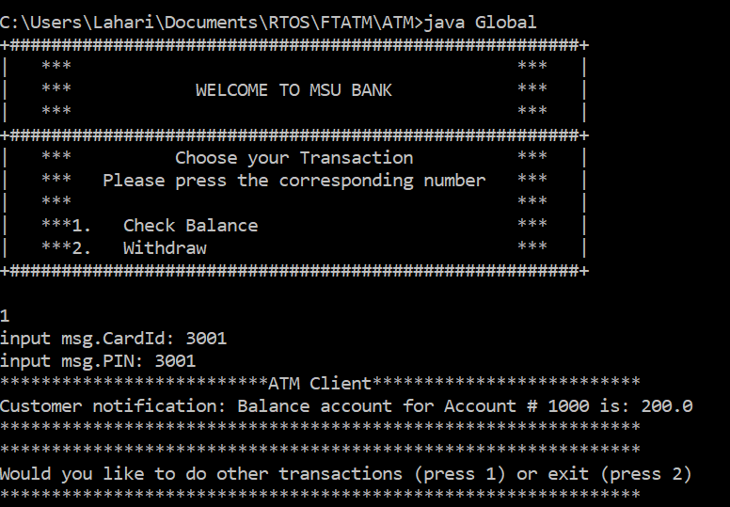

**Fig: 4**

**DAILY LIMIT REACHED FOR 3001:**

* The end user wants to Withdraw some amount with CardId: 3001 and PIN: 3001, it checks if a CardID matches the PIN first. If it matches, then it checks whether the withdrawing amount is over the ***daily debit limit which is $300***.
* In this case, the amount withdrawing by the end user is $101, which is over the daily limit as the user already have debited $200 in his/her account . So we get a message saying **“Daily limit reached”**.

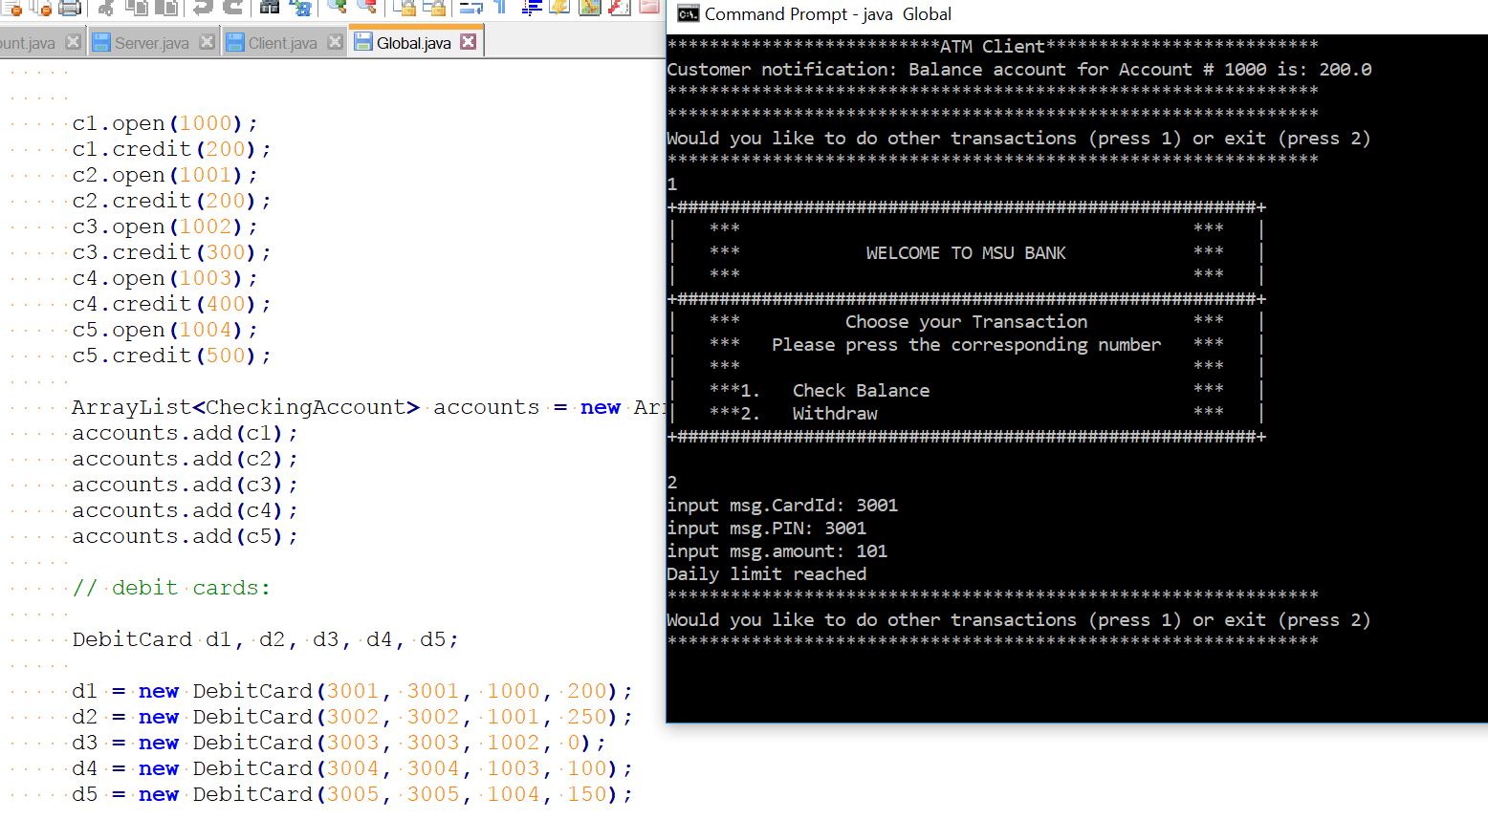

**Fig: 5**

**WITHDRAW FOR 3001:**

* Again, the end user wants to Withdraw some amount with CardId: 3001 and PIN: 3001, it checks if a CardID matches the PIN first. If it matches, then it checks whether the withdrawing amount is over the ***daily debit limit which is $300***.
* In this case, the amount withdrawing by the end user is $100 which is not over as the daily limit so the function withdraws the amount for the corresponding account no. 1000 and updates the daily debit totals for the CardId: 3001 which gives the updates balance for account no. 1000 is $100.00.

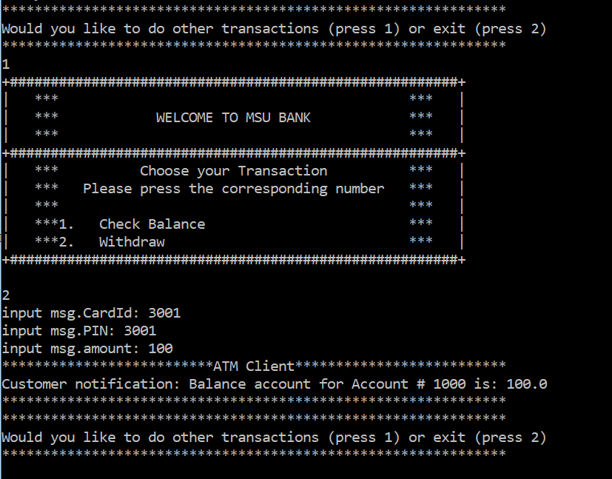

**Fig: 6**

**CHECK BALANCE FOR 3002:**

* Initially, the end user wants to check the balance with CardId: 3002 and PIN: 3002 that first checks if a CardId matches the PIN first, now it returns an account number and then reads the balance for account number:1001 which is $200.

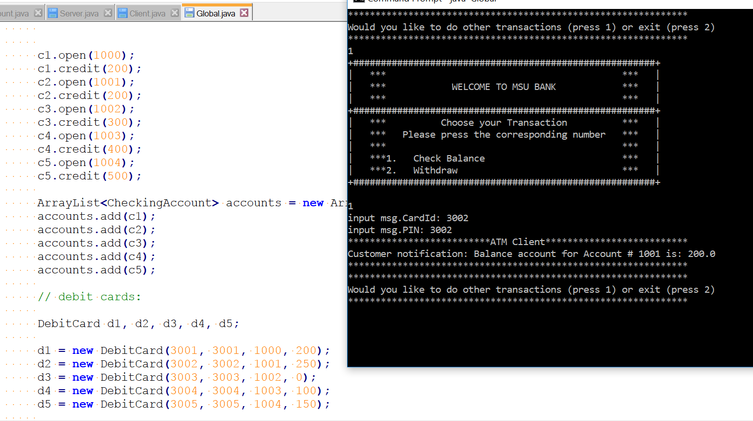

**Fig: 7**

**DAILY LIMIT REACHED FOR 3002:**

* The end user wants to Withdraw amount with CardId: 3002 and PIN: 3002, it checks if a CardID matches the PIN first. If it matches, then it checks whether the withdrawing amount is over the ***daily debit limit which is $300***.
* In this case, the amount withdrawn by the end user is $53,which is over the daily limit as the user already have debited $250 in his/her account. So we get a message saying **“Daily limit reached”**.

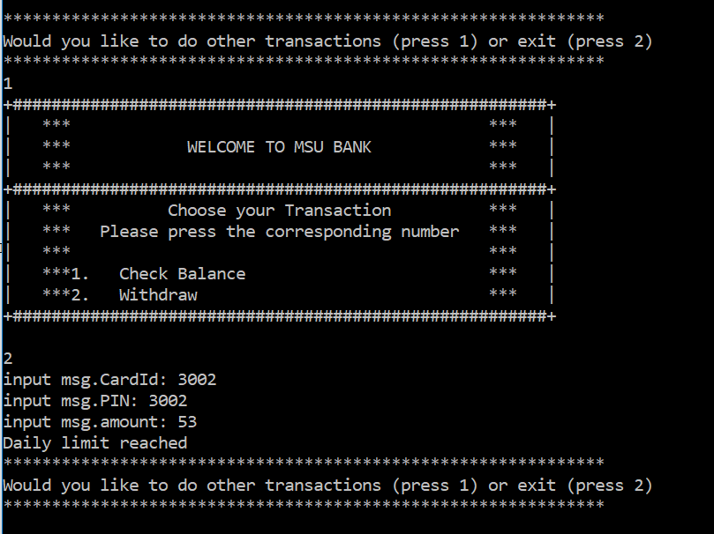

**Fig: 8**

**WITHDRAW FOR 3002:**

* Again, the end user wants to Withdraw some amount with CardId: 3002 and PIN: 3002, it checks if a CardID matches the PIN first. If it matches, then it checks whether the withdrawing amount is over the ***daily debit limit which is $300***.
* In this case, the amount withdrawn by the end user is $40 which is not over as the daily limit so the function withdraws the amount for the corresponding account no. 1001 and updates the daily debit totals for the CardId: 3002 which gives the updated balance for account no. 1001 is $160.00.

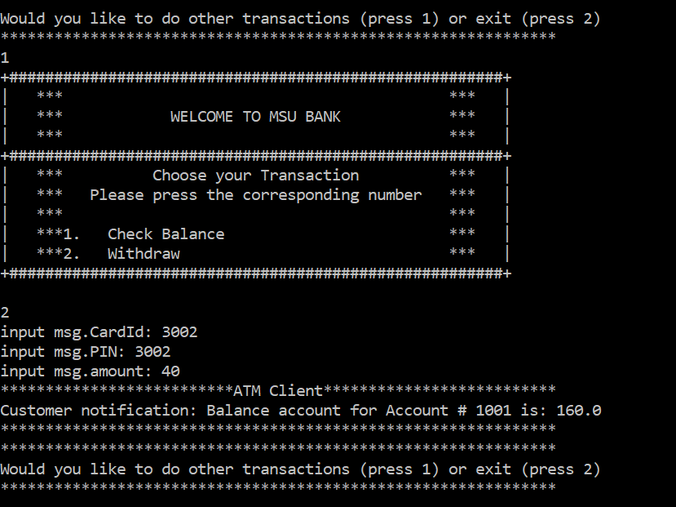

**Fig: 9**

**CHECK BALANCE FOR 3003:**

* Initially, the end user wants to check the balance with CardId: 3003 and PIN: 3003 that first checks if a CardId matches the PIN first, now it return an account number and then reads the balance for account number:1002 which is $300.

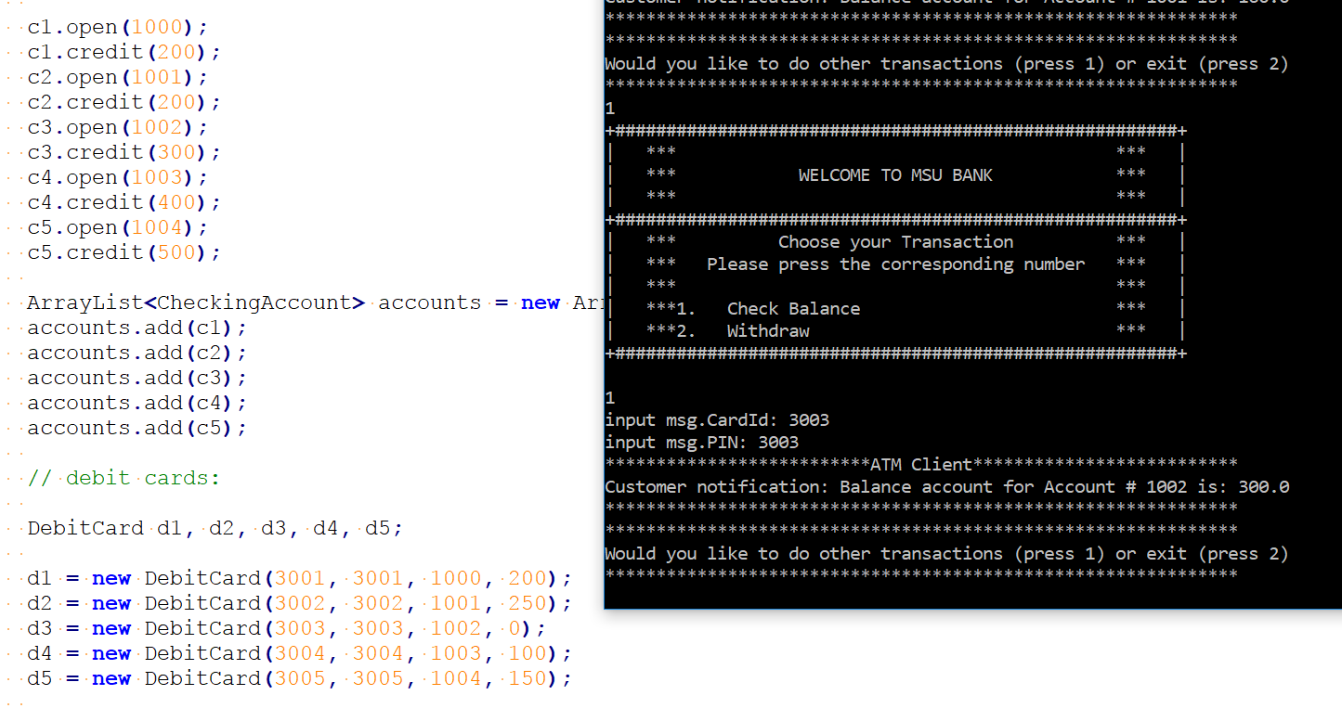

**Fig: 10**

**DAILY LIMIT REACHED FOR 3003:**

* The end user wants to Withdraw some amount with CardId: 3003 and PIN: 3003, it checks if a CardID matches the PIN first. If it matches, then it checks whether the withdrawing amount is over the ***daily debit limit which is $300***.
* In this case, the amount withdrawn by the end user is $307 which is over the daily limit as the user already have debited $300 in his/her account. So we get a message saying **“Daily limit reached”**.

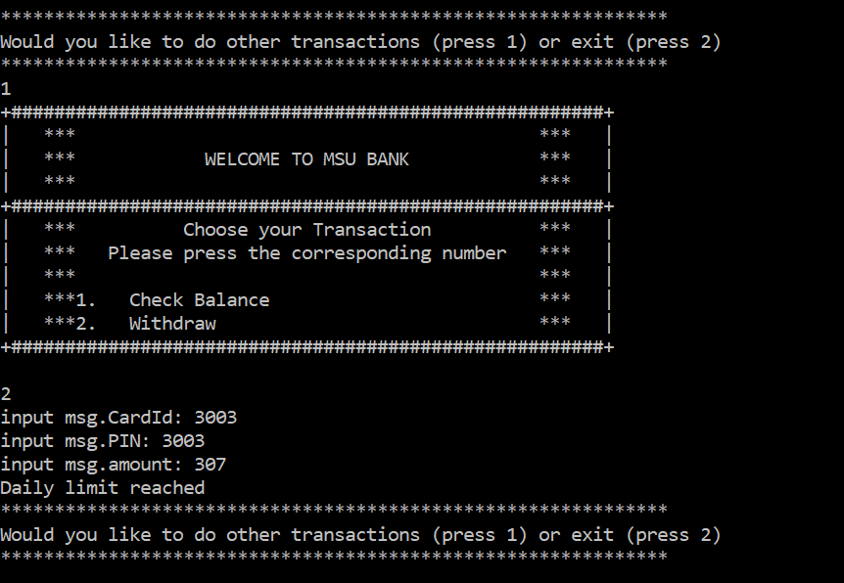

**Fig: 11**

**WITHDRAW FOR 3003:**

* Again, the end user wants to Withdraw some amount with CardId: 3003 and PIN: 3003, it checks if a CardID matches the PIN first. If it matches, then it checks whether the withdrawing amount is over the ***daily debit limit which is $300***.
* In this case, the amount withdrawing by the end user is $300 which is not over as the daily limit so the function withdraws the amount for the corresponding account no. 1002 and updates the daily debit totals for the CardId: 3001 which gives the updates balance for account no. 1002 is $0.0.

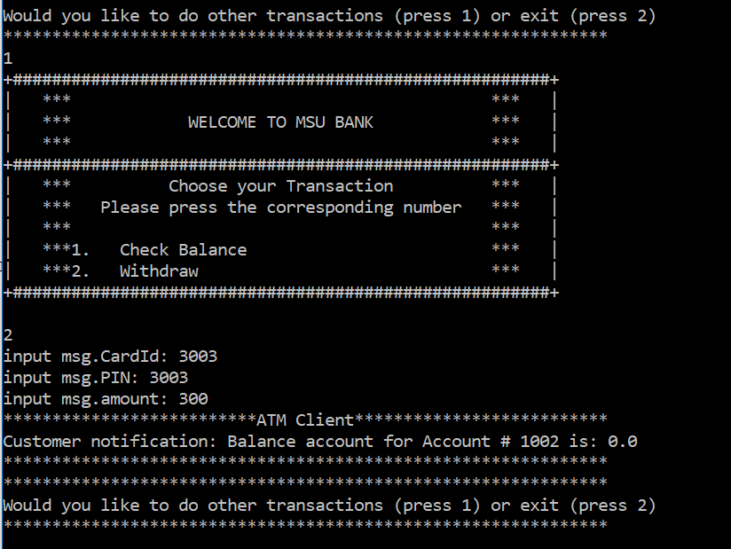

**Fig: 12**

**CHECK BALANCE FOR 3004:**

* Initially, the end user wants to check the balance with CardId: 3004 and PIN: 3004 that first checks if a CardId matches the PIN first, now it return an account number 1003 and then reads the balance for account number:1003 which is $400.

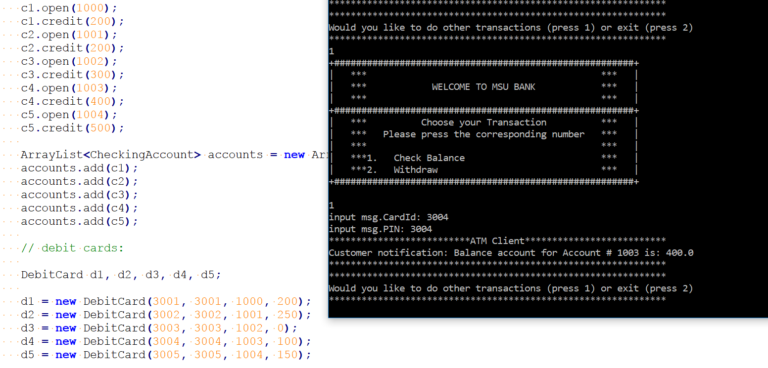

**Fig: 13**

**DAILY LIMIT REACHED FOR 3004:**

* The end user wants to Withdraw some amount with CardId: 3004 and PIN: 3004, it checks if a CardID matches the PIN first. If it matches, then it checks whether the withdrawing amount is over the ***daily debit limit which is $300***.
* In this case, the amount withdrawn by the end user is $240 which is over the daily limit as the user already have debited $100. So we get a message saying **“Daily limit reached”**.

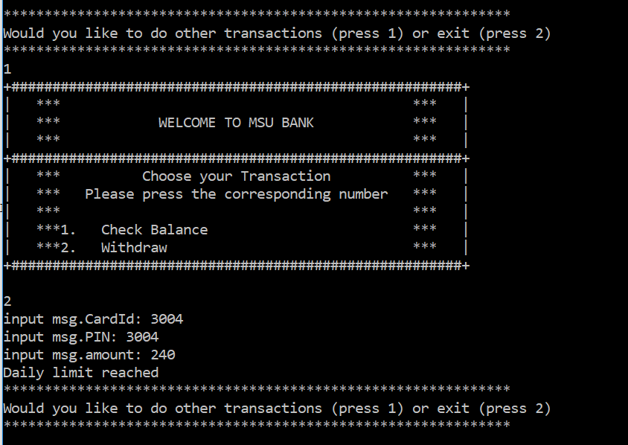

**Fig: 14**

**WITHDRAW FOR 3004:**

* Again, the end user wants to Withdraw some amount with CardId: 3004 and PIN: 3004, it checks if a CardID matches the PIN first. If it matches, then it checks whether the withdrawing amount is over the ***daily debit limit which is $300***.
* In this case, the amount withdrawing by the end user is $120 which is not over as the daily limit so the function withdraws the amount for the corresponding account no. 1003 and updates the daily debit totals for the CardId: 3004 which gives the updated balance for account no. 1003 is $280.0.

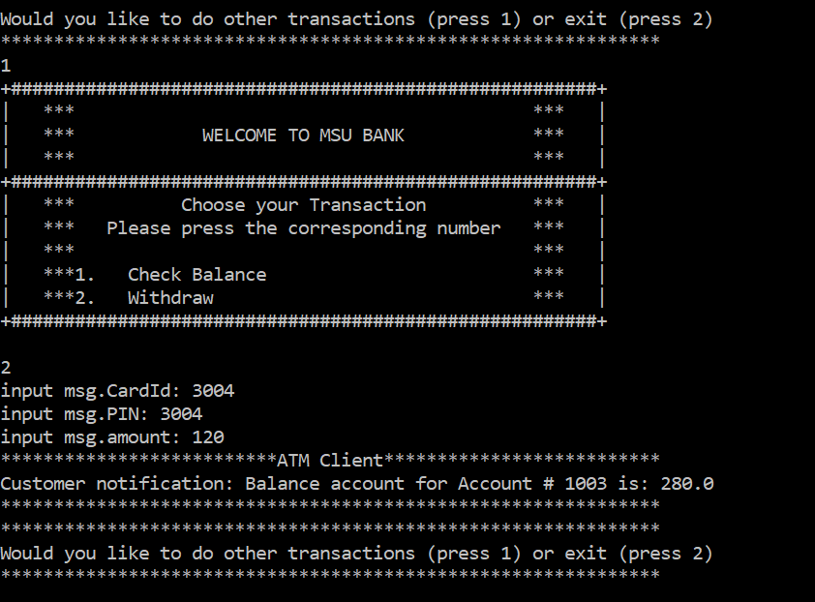

**Fig: 15**

**CHECK BALANCE FOR 3005: FAULTY CASE**

* Initially, the end user wants to check the balance with CardId: 3005 and PIN: 3005 that first checks if a CardId matches the PIN first, now it return an account number 1004 but its transaction will trigger the Failover which displays the message

***“Count 3 times: Server does not respond”*** as the non-fault tolerant server was running at first.

* Then later on when the failover occurs the request has been placed to the fault-tolerant server which completes the transaction by giving the balance amount $500 for the account number 1004.

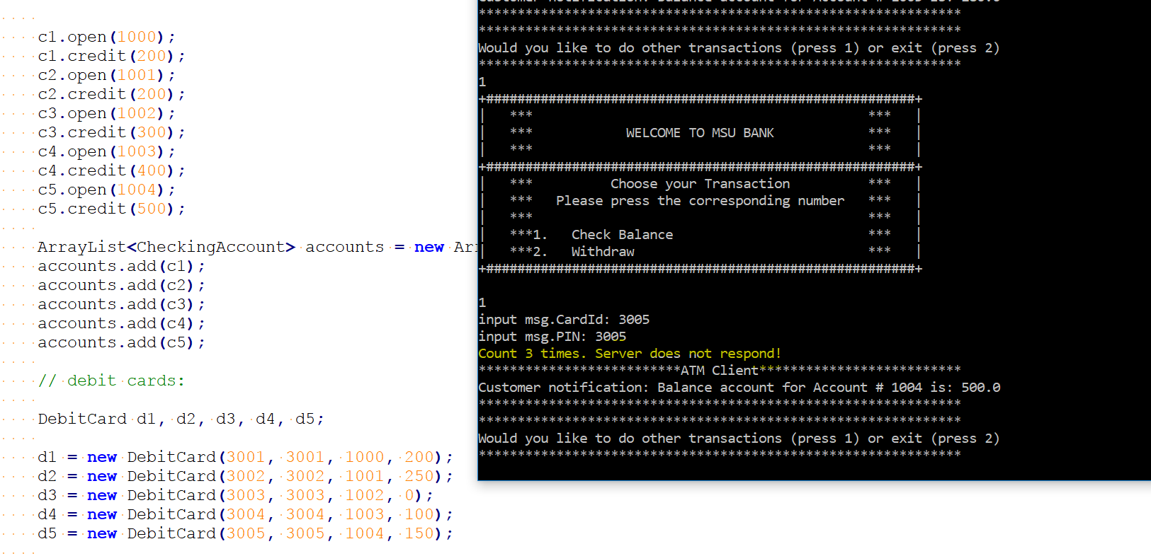

**Fig: 16**

**DAILY LIMIT REACHED FOR 3005:**

* The end user wants to Withdraw some amount with CardId: 3005 and PIN: 3005, it checks if a CardId matches the PIN first. If it matches, then it checks whether the withdrawing amount is over the ***daily debit limit which is $300***. But its transaction will trigger the Failover which displays the message ***“Count 3 times: Server does not respond”*** as the non-fault tolerant server was running at first.
* In this case, the amount withdrawn by the end user is over the daily limit which is $165 as the user already has already debited $150. When the failover occurs the request has been placed to the fault-tolerant server here which completes the transaction by displaying a message **“Daily limit reached”**.

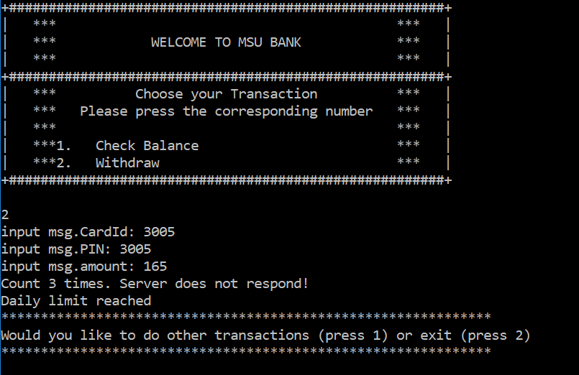

**Fig: 17**

**WITHDRAW FOR 3005:**

* Again, the end user wants to Withdraw some amount with CardId: 3005 and PIN: 3005, it checks if a CardId matches the PIN first. If it matches, then it checks whether the withdrawing amount is over the ***daily debit limit which is $300***.
* In this case, the amount withdrawn by the end user is $30 which is not over the daily limit but its transaction will trigger the Failover which displays the message ***“Count 3 times: Server does not respond”*** as the non-fault tolerant server was running at first.
* Once the failover occurs the request has been placed to the fault-tolerant server. The function withdraws the amount for the corresponding account no. 1004 and updates the daily debit totals for the CardId: 3005 which gives the updated balance for account no. 1004 is $470.0.
* All the three scenarios for fault tolerant server are executed individually to show the heart beat message.

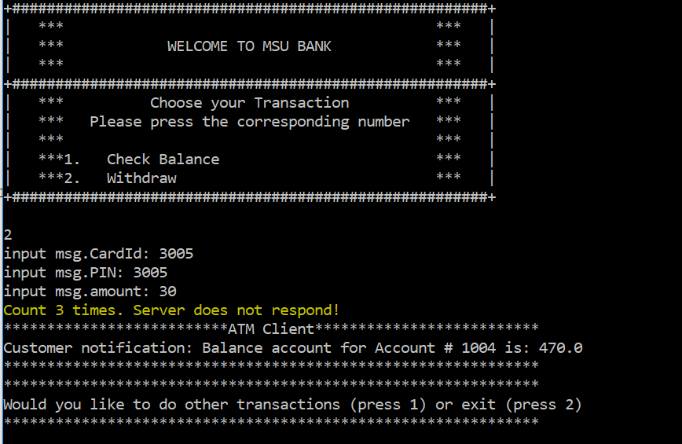

**Fig: 18**